Project Development Phase
Testing and Validation
Date | 23 October 2026
Team ID | --------------------------
Project Name | Car Rental Request Automation in ServiceNow Using Service Catalog and Workflows
Maximum Marks | 4 marks

Purpose
The testing and validation phase is carried out to confirm that the Car Rental Request Automation system functions correctly and meets the defined requirements. This phase ensures that the Service Catalog item, Flow Designer automation, approval process and notification mechanism work together without manual intervention.
Testing focuses on validating the complete workflow, starting from the car rental order placed by the user, through the email notification and approval by the administrator, to the final status of the request visible to the user. The goal is to ensure system accuracy, stability and a smooth user experience.
Test Environment
- Platform: ServiceNow (Personal Developer Instance)
- Modules Utilized:
- Service Catalog (Car Rental Request catalog item)
- Flow Designer (approval and fulfilment automation)
- Approvals (sysapproval_approver) and Requested Items (sc_req_item)
- Email notifications
- User Roles Involved:
- Employee / Requester
- Administrator / Approver (office registration)
Test Scenarios Executed
The following scenarios were tested to validate system functionality:
- Submission of a car rental request through the catalog item
- Capture of pickup, drop, duration and car details
- Email notification to the office / administrator
- Approval of the request by the administrator
- Automatic update of the request status and verification by the user
Testing Execution Details
Scenario 1: Car Rental Request Submission
- The user opens the Car Rental Request item from the Service Catalog.
- The required details are entered, including:
- Requestor
- Requested Date
- Pickup Location (starting point)
- Drop Location (ending point)
- Duration
- Car Type
- Reason
- The user clicks Order Now. The request is submitted without validation errors and the message “Thank you, your request has been submitted” is displayed with the Request Number (REQ0010002 in this test).
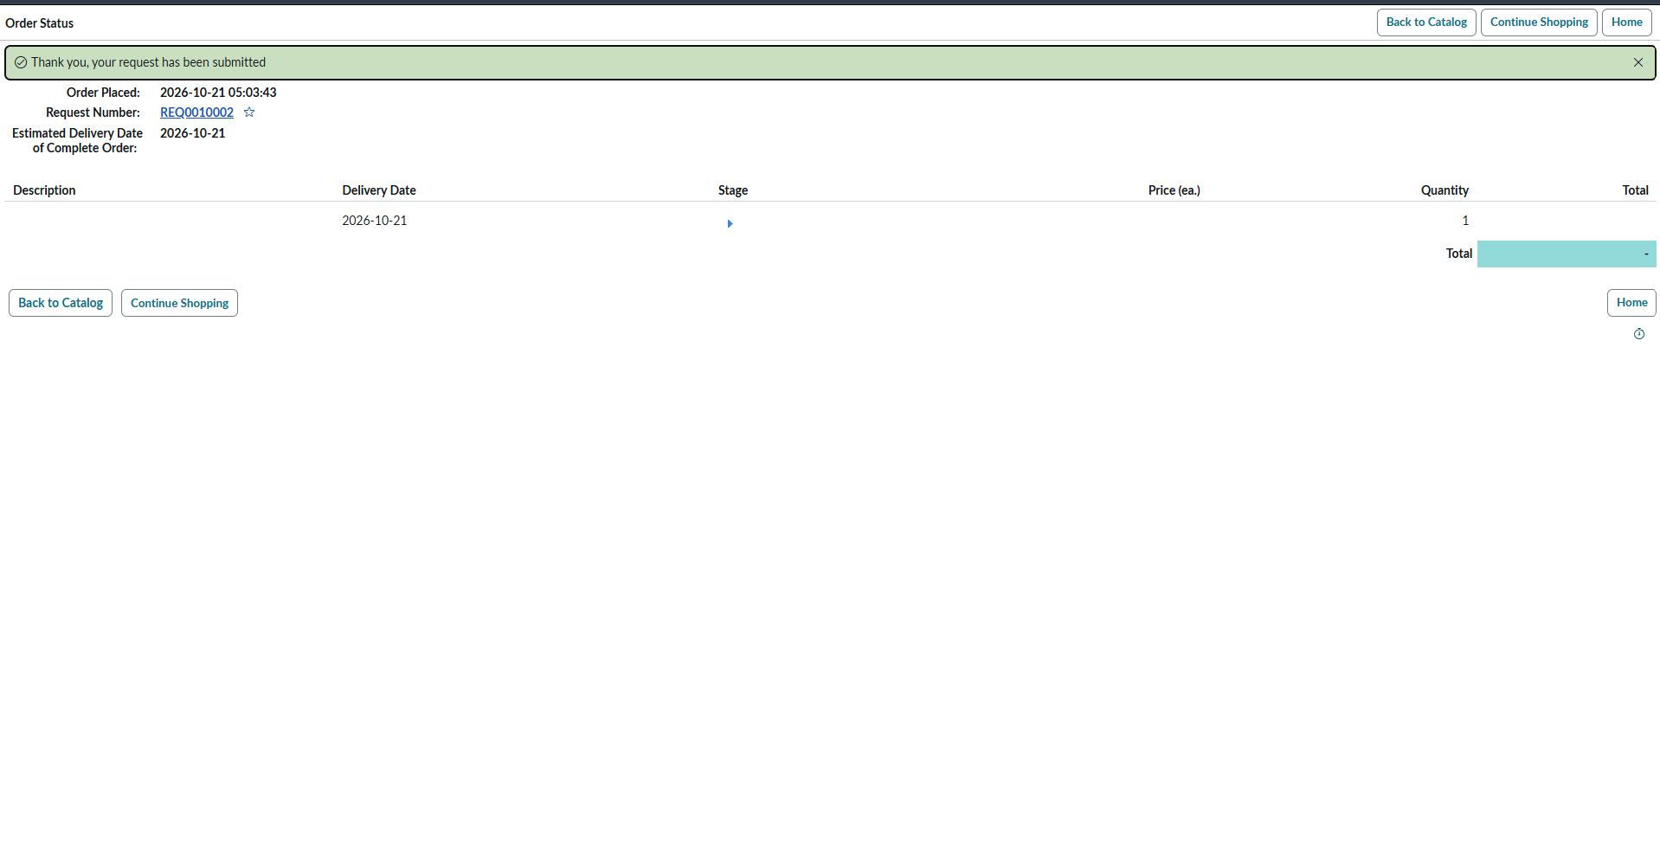
Figure 1: Order Status page after submitting the car rental request
Scenario 2: Flow Trigger and Email Notification
- On submission, the Flow Designer automation is triggered automatically and creates the request (REQ) and requested item (RITM) records.
- An email notification is sent to the office / administrator for the new car rental request.
- The administrator checks the email and confirms that the request details are received correctly.
Scenario 3: Administrator Approval
- The administrator opens the approval for the requested item and selects Approve for the vehicle request.
- The Approvals list shows the approval record against the requested item (RITM0010003 in this test) in the Approved state, approved by the administrator account, with the date and time recorded.
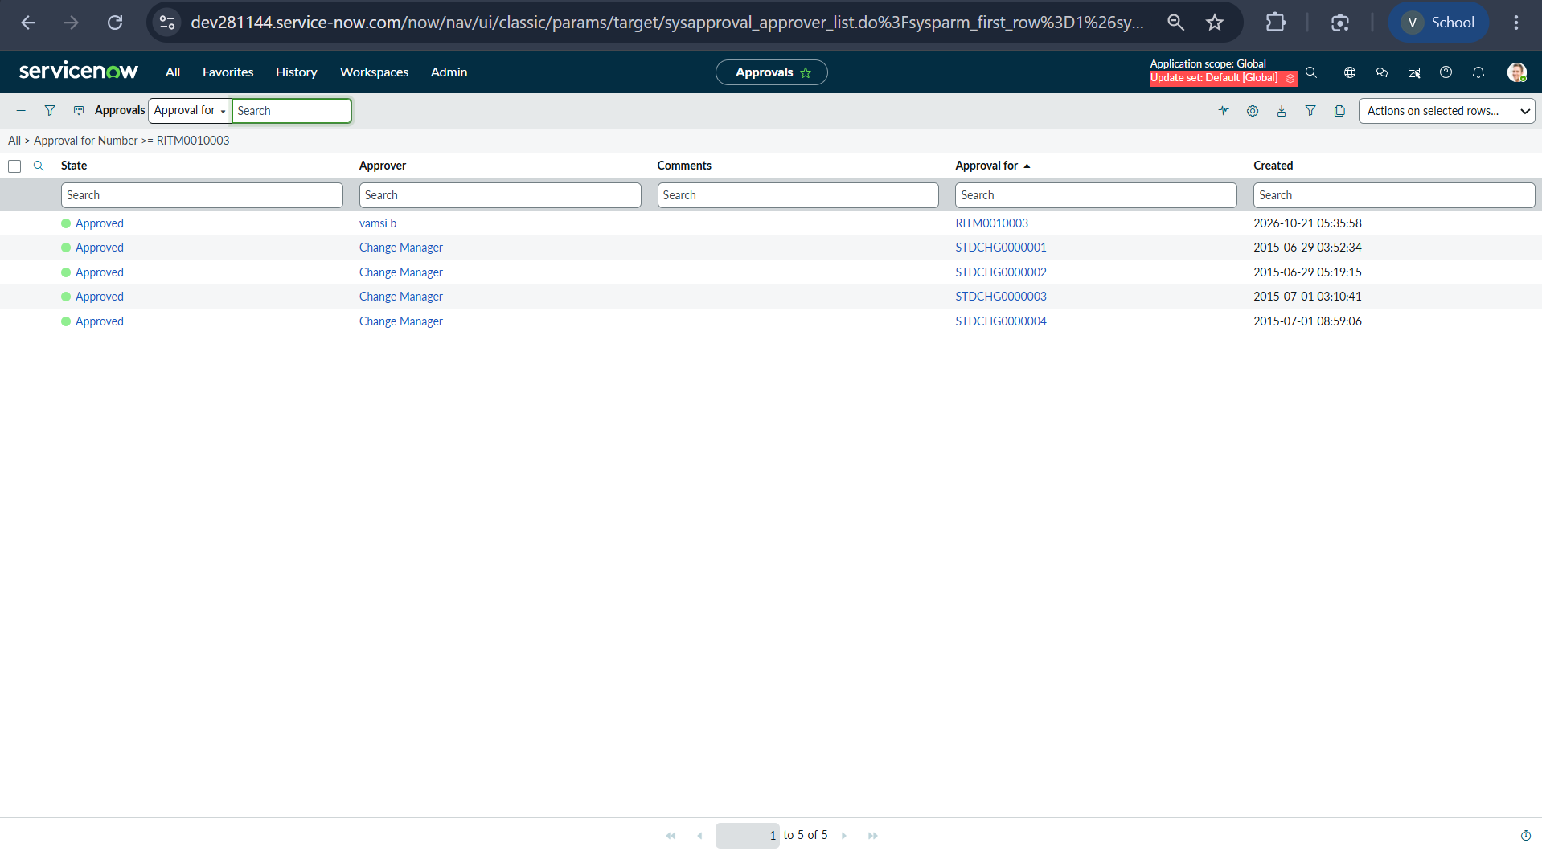
Figure 2: Approval record in Approved state for the requested item
Scenario 4: Request Status Verification by the User
- After approval, the user opens the requested item (RITM0010001 in this test) to verify the result.
- The item is Car Rental Request, the Stage shows “Request Approved” and the State shows “Closed Complete”.
- All submitted variables are stored correctly: Requested Date 2026-10-21, Pickup Location visakhapatnam, Drop Location jonnada, Duration 1 hour, Car Type fortuner and Reason family function.
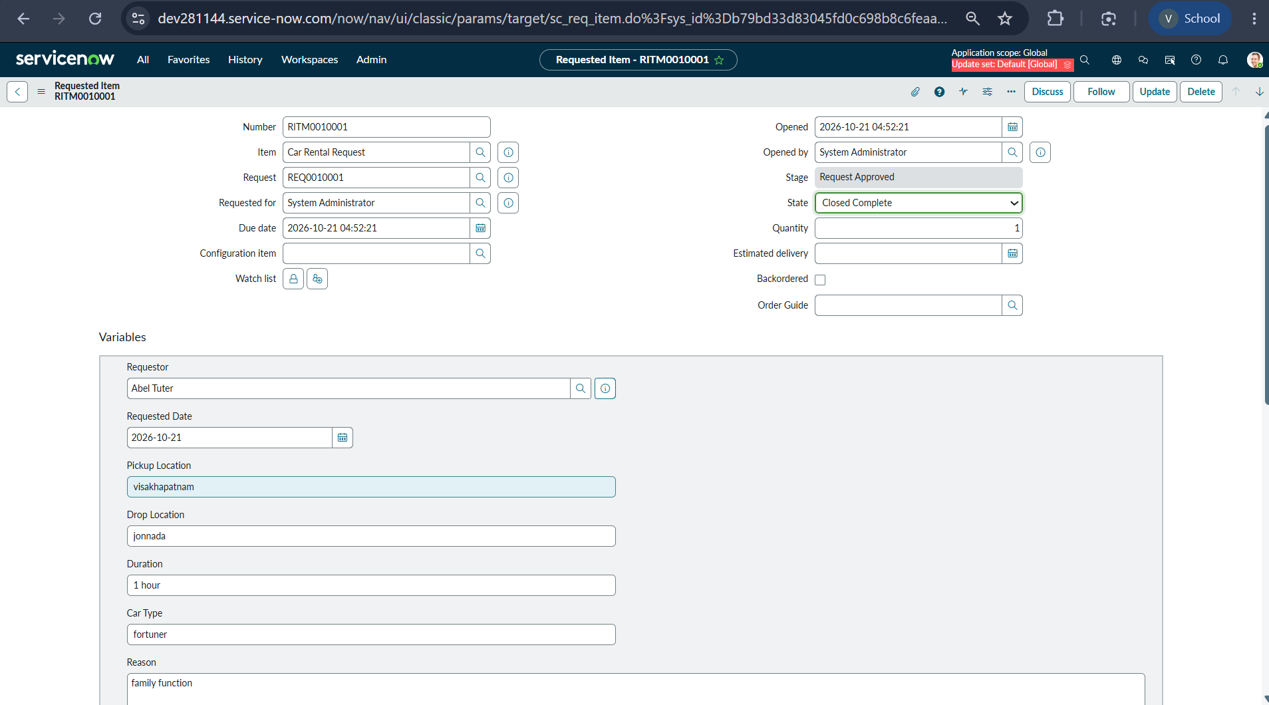
Figure 3: Requested item showing Request Approved stage and Closed Complete state
Test Results
Test Case | Expected Result | Actual Result | Status
Submit car rental request | Request submitted, REQ number generated | REQ0010002 generated with confirmation message | Pass
Flow Designer trigger | Flow runs on catalog submission | REQ/RITM created and flow executed | Pass
Email to administrator | Notification received by office / administrator | Administrator checked the email successfully | Pass
Administrator approval | Approval recorded as Approved | Approval record in Approved state | Pass
User verification | Stage and state updated, variables stored | Request Approved, Closed Complete, values correct | Pass
Summary
The testing results confirm that the Car Rental Request Automation system operates reliably across all tested scenarios. Car rental orders, email notification, administrator approval and automatic status updates function correctly, ensuring a consistent and error-free request process. The system is validated to be ready for deployment and real-time usage.

